Vegetation Community Monitoring Protocol for the Heartland Inventory and Monitoring Network

Standard Operating Procedure 7: Measuring Ground Flora

Version 2.00 (2018)

Revision History Log:

| Previous Version # | Revision Date | Author | Changes Made | Reason for Change | New Version # |
| --- | --- | --- | --- | --- | --- |
| 1.0 | 2018 | S.A. Leis | Improving clarity, consolidate datasheets, add new detail for woody species data collection, and reorganize to match workflow. | Provide clarity | 2.0 |
|  |  |  |  |  |  |
|  |  |  |  |  |  |
|  |  |  |  |  |  |

This SOP gives step-by-step instructions for obtaining frequency and cover estimates of herbaceous and shrub species in the nested circular plots. This SOP also describes the procedure for filling in the Ground Flora datasheet and Unknown Data Sheet. Prior to collecting ground flora data, complete the site set up described in SOP 5-Monitoring Site Setup, SOP 4-Documenting Site Disturbance, and collect the Ground Cover data described in SOP 6-Measuring Ground Cover.

Resources

Equipment

See SOP 5-Monitoring Site Set up for additional equipment.

Additional items for measuring ground flora:

* Clip boards (2)
* Data sheets: Ground Flora, Unknown plant specimen
* Field guides and identification aides
* Pin flags (to mark questionable plants)
* Plant press
* Plant species list for site
* Tree list
* Hand lens (for each botanist)
* 6-inch ruler
* Sharpie type markers
* Unknown specimen book
* Write-In-Rain blank data sheets (to avoid confusion with regular paper, keep labeled)
* Plant press (1-2), Ziplock bags for collecting specimens
* Laminated cover class cards

Sampling teams

One sampling team, each consisting of a scribe and a botanist, is assigned to a transect line. The sampling team is responsible for the following: (1) assembling their sampling frame; (2) collecting all of the required data, including metadata for the transect and plot data; (3) collecting and describing any unknown plants encountered and relaying the information to the project botanist before leaving the site; and (4) ensuring that all equipment, including sampling frames, meter tape, flags, flagging, data sheets and clip boards, make it to the next site.

Collecting and Recording Data

Collecting Species Data

With the nested subplots located inside the larger sampling frame, it is time to begin collecting data. Before collecting data for any plot, double check that the plot’s location corresponds with the plot number on the data sheet. For each plot (e.g., 10A), there is a data sheet labeled with the plot number and the names of the species found in the plot during previous sample efforts (Figure 7.0). That list of species is not shared with the observer until he/she has completed their search of all subplots for plants.

Ground cover data is collected first (see SOP 6-Measuring Ground Cover) followed by species data. Record herbaceous and shrub species, but not tree species (see Regeneration, below, over SOP 10-Measuring Midstory and Overstory Trees for trees. Species data collection begins in the smallest subplot frame (0.01 m2). The observer identifies all herbaceous plants and woody shrubs rooted within this frame to species (if possible). If a plant is rooted entirely underneath the frame, it is not counted as being within that subplot. Generally, the subplot frames sit on or close to the ground when sampling. However, tall or dense vegetation, rocks, or an otherwise uneven surface may prevent this. In such cases, simply estimate as fairly as you can whether a borderline species appears to be rooted inside or outside the appropriate frame. All species with live plant material rooted within the subplot are recorded on the data form and a check is made in the 0.01 m2 column next to each species as it is found.

Once all plant species have been identified within the 0.01 m2 subplot frame, the observer moves to the next largest subplot identifying any additional species there, and so on until the 10 m2 -subplot is reached (0.01 🡪0.1 🡪 1.0 🡪10 m2). Within each consecutively greater sized subplot frame, all new plants encountered are called and recorded. When recording, a species should always be recorded in the first subplot frame in which it is located.

The search for plants in the 10 m2 plot is facilitated by the cross-bars separating the plot into four quarters or in woodlands, the rope on the center stake serves this purpose. The observer must take care not to trample the plot. This is integral to the success of any long-term monitoring project as well as the double sample effort to follow the initial sampling. Once the observer has completed his/her search of the 10 m2 plot, the species list is consulted to look for possible mistakes in species identifications and missed species. This list provides the names, but not associated cover values, of species previously collected in a plot for comparison to those currently collected. If a species was previously collected but is now missing, the plot is double-checked to ensure the species has not been overlooked. The species may be absent but may surface in a later sampling period, or its record in previous years may reflect a change in species identification or sampling error. At this point, any lingering questions on species identification should be communicated to the project botanist or leader. He/she will decide if it is necessary to fill out an “unknown” record and give the species of question an unknown number and name. See SOP 8-Processing Unknown Specimens for more details.

Sometimes species determinations of individual plants encountered in sampling are difficult or uncertain. When this situation occurs, the area surrounding the plot should be searched, looking particularly for a specimen of the unknown that is in flower or fruit, or perhaps is a specimen from last year with its flowering stalk still intact. These may assist in correctly identifying the species in the plot. Most of these plants are not entirely “unknown” species. Rather, they are of a species that is known but sometimes difficult to distinguish from another given the timing of sampling. For example, small *Bouteloua curtipendula* plants may be confused with *Bouteloua hirsuta*. Both of these species are common and often confidently identified during our various sampling procedures. If the evidence does not favor one species over another, then the next broader taxonomic grouping can be recorded. In the above example, “*Bouteloua* spp.” could be recorded. This name would be sufficient until species-level identification is available (e.g., during a subsequent sampling the plant is found in the same location in flower, seed, or fruit, aiding correct identification).

Some woody species can take both tree and shrub forms depending on the landscape context and disturbance history. The distinction of whether a plant is a shrub or tree is critical to knowing what observations are needed for that plant. To aid this process, we have developed a table that provides guidance for the treatment of many of these confusing species (Table 7.1). The table will be consulted in the field using a hard copy sheet. If observers are still unclear, collect observations both as a shrub and as a tree, but flag the data so that a decision can be made by the project leader prior to data entry.

Some species are commonly lumped to genus because consistent vegetative identification is difficult/inconsistent or the taxonomy for that group of plants is unstable. For those groups, continue to lump them as indicated on the list of previously identified species for each plot. If a more specific identification is possible, note it in parentheses or in the cumulative species list with a note to draw attention during data entry. If uncertainty over the level of specificity occurs, collect the data at two levels (genus only and genus with species) with specific notes that a choice should be made by the project leader prior to data entry. The following are commonly lumped to genus: *Oxalis, Carex, Dichanthelium, Cyperus, Eleocharis*, *Viola, Vitis*, and *Juncus*. For trees at the regeneration level, lump *Ulmus* spp.and *Fraxinus* spp.. More mature trees can be identified to species in most cases.

For species that cannot be readily identified when they are encountered, refer to the SOP 8-Processing Unknown Specimens.

Estimates of Foliar Cover

Once the species list for the plot is complete, cover estimates are recorded. For each species present, a visual estimate of foliar cover is made within the 10 m2 sampling plot (Figure 7.0). The estimate is a vertical projection of foliar cover onto the ground surface. Put another way, the cover is equivalent to the % of light intercepted by vegetation. This estimation excludes gaps in the plant canopy. The foliar cover of each species is estimated using a cover class index modified from Daubenmire (1959, Table 7.0). Only species rooted in the plot are recorded and included in estimates of foliar cover. Each individual percentage value alone cannot exceed 100%, but when combined the cover value for a plot may be greater than 100%. The table provides visual cues to aid the estimation process.

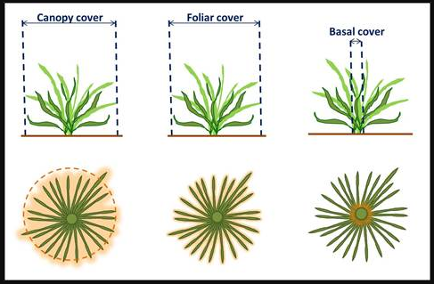

Figure 7.0. Illustration of methods of estimating plant cover. This SOP uses the foliar cover method of estimation. Image credit L. Svejcar, used. Permission via Creative Commons Attribution NonCommercial 4.0 International License.

Table 7.0. Modified Daubenmire cover value scale used to determine herbaceous/shrub species cover for the HTLN Parks.

| Cover Class Code | Range of Cover (%) | Class Midpoint (%) | Upper Break-point Visual Cue |
| --- | --- | --- | --- |
| 7 | 95.1-100 | 97.5 | 10 m2-hoop full extent (100%) |
| 6 | 75.1-95.0 | 85.0 | Subtract ½ of 1m2-hoop from 10 m2-hoop (95%) |
| 5 | 50.1-75.0 | 62.5 | 3-¼ sections created by cross-ropes of 10 m2-hoop (75%) |
| 4 | 25.1-50 | 37.5 | 2-¼ sections created by cross-ropes of 10 m2-hoop (50%) |
| 3 | 5.1-25.0 | 15.0 | ¼ sections created by cross-ropes of 10 m2-hoop (25%) |
| 2 | 1.1-5.0 | 2.5 | ½ of 1 m2-hoop (5%) |
| 1 | present-1.0 | 0.5 | 0.1 m2-hoop (1%) |

Field version

| **Cover Class** | **Range (%)** | **Upper Break-point Visual Cue** |
| --- | --- | --- |
| 7 | 95.1-100 | 10 m2-hoop full extent (100%) |
| 6 | 75.1-95.0 | Subtract ½ of 1m2-hoop from 10 m2-hoop (95%) |
| 5 | 50.1-75.0 | 3-¼ sections created by cross-ropes of 10 m2-hoop (75%) |
| 4 | 25.1-50 | 2-¼ sections created by cross-ropes of 10 m2-hoop (50%) |
| 3 | 5.1-25.0 | ¼ sections created by cross-ropes of 10 m2-hoop (25%) |
| 2 | 1.1-5.0 | ½ of 1 m2-hoop (5%) |
| 1 | present-1.0 | 0.1 m2-hoop (1%) |

Regeneration: Seedling & Sapling Measurement

After completing the ground flora cover measurements, scan the 10 m2 plot for tree regeneration. Trees are designated on in table (Table 7.1) for consistency. For individuals of the tree species on this list with DBH < 5 cm (tree regeneration), sampling occurs in the ten 10-m2 plots after ground cover and ground flora sampling is completed. For each 10-m2 plot, the number of stems for each tree species are tallied in three size classes:

* 1. Seedlings: < 0.5 m in height
  2. Small saplings: > 0.5 m in height and DBH 0.1 - 2.53 cm
  3. Large saplings: > 0.5 m in height and DBH > 2.54 but < 5.0 cm

Resprouts that originate below ground will be counted as individual stems based on their size class. If the resprouts originate from an above-ground stump or trunk, only the parent would be recorded based on overstory or regeneration size classes (SOP 10-Measuring Midstory and Overstory Trees). The disturbance assessment sheet can be used to denote tree cutting or disturbances that stimulate resprouting within the site.

Calipers are helpful for checking the DBH of saplings. If unsure of identification of small *Quercus* (oak) species, lump into white oak group or red oak group categories. *Carya* (hickory) species are also difficult to separate at this stage and can be lumped to *Carya* sp. Regeneration data are recorded in the regeneration grid on the upper right side of the ground flora data sheet. Estimates of foliar cover are not measured for these species. However, if a species designation as shrub or tree is unclear, record the data both ways highlighting that a decision should be made prior to data entry.

Recording Data

For each transect within a site, a packet of datasheets is generated using the Vegmon database tool. See Figure 7.0 for an example. The packet includes a datasheet for each of the nested plots on a transect (typically n = 5). When first arriving at a site, each sampling team is handed a set of data sheets that corresponds to the plots along the transect to which they are assigned. When starting each new nested plot, it is important to make sure data is being transcribed to the correct data sheet. Record the following information on each data sheet:

Datasheet Header

Date**:** Include month (mm) / day (dd) / year (yy).

Collector’s initials**:** The unique initials of the first and last name of each person in the field crew collecting data. If initials of two or more persons are the same, include a middle initial or some other distinguishing initial.

Start Time**:** Time when field crew begins collecting plot data at the monitoring site.

End time**:** Time when field crew finished collecting plot data at the monitoring site.

Data entered (initials)**:** Date when data is entered into the computer. Include month (mm) / day (dd) / year (yy) and the initials of the person conducting the data entry.

Verified (initials): Date when data is verified by comparing the paper data to the printout of the data in the database. Include month (mm) / day (dd) / year (yy) and the initials of the person conducting the verification.

Datasheet Body

Species: Species encountered. Enter a minimum of 4 letters each of the genus and species. The entire species may be written for clarity where the 4X4 scheme can result in the possibility of two species e.g. ***Acer******sacc****harum* or ***A.******sacc****harinum* and ***Viola peda****ta* and***V. peda****tifida*.

0.01, 0.1, 1.0, 10: Mark the box that corresponds to the nested subplot frame that a plant is first encountered in with an X.

Cover: Enter the cover class value for each plant recorded based on abundance in the 10-m2 plot.

Cumulative species list: List of species previously encountered in the plot for reference.

All datasheets should be checked for completeness prior to moving to the next plot. Datasheets should also be reviewed by the project leader for completeness prior to leaving a monitoring site.

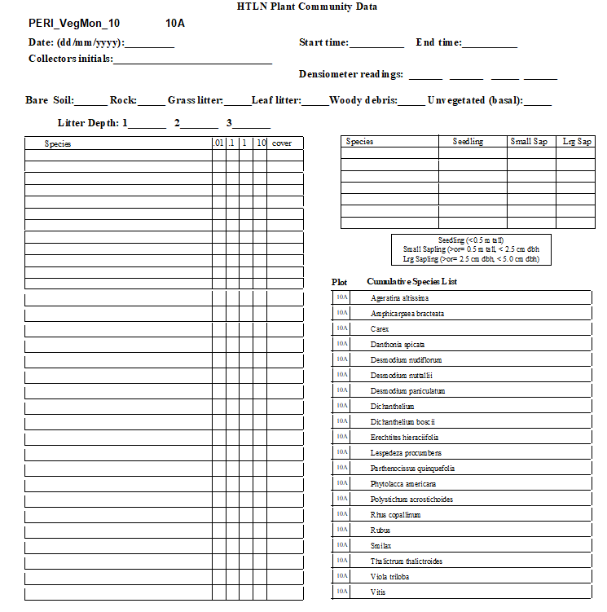

**Figure 7.1** Ground Flora datasheet, example for PERI site 10 plot 10A.

**Table 7.1.** Woody species data collection method designation. This list includes the vast majority of species that have potential to cause confusion in the field. SOP-7 Measuring Ground Flora, SOP 10-Measuring Midstory and Overstory Trees. Shrubs and tree regeneration will be collected as per methods described in this SOP

| Species Code | Species name | Plant type |
| --- | --- | --- |
| ACNE2 | *Acer negundo* | tree |
| ACRU | *Acer rubrum* | tree |
| ACSA2 | *Acer saccharinum* | tree |
| ACSA3 | *Acer saccharum* | tree |
| AEGL | *Aesculus glabra* | tree |
| ALNUS | *Alnus* spp. | tree |
| AMELA | *Amelanchier* spp. | tree |
| AMAR3 | *Amelanchier arborea* | tree |
| AMLA | *Amelanchier laevis* | tree |
| ARSP2 | *Aralia spinosa* | shrub |
| BETUL | *Betula* spp. | tree |
| BENI | *Betula nigra* | tree |
| BEPA | *Betula papyrifera* | tree |
| CACA18 | *Carpinus caroliniana* | tree |
| CARYA | *Carya* spp. | tree |
| CAAL27 | *Carya alba* | tree |
| CACO15 | *Carya cordiformis* | tree |
| CAGL8 | *Carya glabra* | tree |
| CAOV2 | *Carya ovata* | tree |
| CATE9 | *Carya texana* | tree |
| CAPUO | *Castanea pumila var. ozarkensis* | tree |
| CEOC | *Celtis occidentalis* | tree |
| CELTI | *Celtis* spp. | tree |
| CETE | *Celtis tenuifolia* | tree |
| CECA4 | *Cercis canadensis* | tree |
| CORNU | *Cornus* spp. | shrub |
| COAL2 | *Cornus alternifolia* | tree |
| CODR | *Cornus drummondii* | shrub |
| COFL2 | *Cornus florida* | tree |
| COFO | *Cornus foemina (*ID likely *drummondii*) | shrub |
| CORA6 | *Cornus racemosa* | shrub |
| CORU | *Cornus rugosa* | shrub |
| CRATA | *Crataegus spp* | tree |
| DIVI5 | *Diospyros virginiana* | tree |
| ELUM | *Elaeagnus umbellata* | shrub |
| EUAT3/EUAT5 | *Euonymus atropurpureus* | shrub |
| FRCA13 | *Frangula caroliniana* | tree |
| FRAXI | *Fraxinus* spp. | tree |
| FRAM2 | *Fraxinus americana* | tree |
| FRNI | *Fraxinus nigra* | tree |
| FRPE | *Fraxinus pensylvanica* | tree |
| GLTR | *Gleditsia triacanthos* | Tree |
| ILDE | *Ilex decidua* | tree |
| ILOP | *Ilex opaca* | tree |
| JUNI | *Juglans nigra* | tree |
| JUNIP | *Juniperus* spp. | tree |
| JUVI | *Juniperus virginiana* | tree |
| LIVU | *Ligustrum vulgare* | Tree |
| LIBE3 | *Lindera benzoin* | shrub |
| LIST2 | *Liquidambar styraciflua* | Tree |
| LITU | *Liriodendron tulipifera* | Tree |
| MAPO | *Maclura pomifera* | tree |
| MALUS | *Malus* spp. | tree |
| MORUS | *Morus* spp. | tree |
| MOAL | *Morus alba* | tree |
| MORU | *Morus rubra* | tree |
| NYSY | *Nyssa sylvatica* | tree |
| OSVI | *Ostrya virginiana* | tree |
| PIEC2 | *Pinus echinata* | tree |
| PIPO | *Pinus ponderosa* | tree |
| PIST | *Pinus strobus* | tree |
| PLOC | *Platanus occidentalis* | tree |
| POPUL | *Populus* spp. | tree |
| POGR4 | *Populus grandidentata* | tree |
| POTR5 | *Populus tremuloides* | tree |
| PRUNU | *Prunus* spp*.* | tree |
| PRAM | *Prunus americana* | shrub |
| PRHO | *Prunus hortulana* | tree |
| PRPU3 | *Prunus pumila* | shrub |
| PRSE2 | *Prunus serotina* | tree |
| PRVI | *Prunus virginiana* | shrub |
| PTTR | *Ptelea trifoliata* | tree |
| QUERC | *Quercus* spp. | tree |
| QUAL | *Quercus alba* | tree |
| QUCO2 | *Quercus coccinea* | tree |
| QUEL | *Quercus ellipsoidalis* | tree |
| QUIM | *Quercus imbricaria* | tree |
| QUMA2 | *Quercus macrocarpa* | tree |
| QUMA3 | *Quercus marilandica* | tree |
| QUMU | *Quercus muehlenbergii* | tree |
| QUPA2 | *Quercus palustris* | tree |
| QURU | *Quercus rubra* | tree |
| QUSH | *Quercus shumardii* | tree |
| QUST | *Quercus stellata* | tree |
| QUVE | *Quercus velutina* | tree |
| REDOAK | *Red oak group* | tree |
| RHAMN | *Rhamnus* spp. | shrub |
| RHCA3 | *Rhamnus cathartica* | shrub |
| RHLA | *Rhamnus lanceolata* | shrub |
| RHCO | *Rhus copallinum* | shrub |
| RHGL | *Rhus glabra* | shrub |
| ROPS | *Robinia pseudoacacia* | tree |
| SANIC4 | *Sambucus nigra ssp. canadensis* | shrub |
| SAAL5 | *Sassafras albidum* | tree |
| SILAA4 | *Sideroxylon lanuginosum ssp. albicans* | shrub |
| SILAL3 | *Sideroxylon lanuginosum ssp. lanuginosum* | shrub |
| STTR | *Staphylea trifolia* | shrub |
| TIAM | *Tilia americana* | tree |
| ULMUS | *Ulmus spp* | HOME and PIPE prairie-shrub  Elsewhere-tree |
| ULAL | *Ulmus alata* | tree |
| ULAM | *Ulmus americana* | tree |
| ULPU | *Ulmus pumila* | tree |
| ULRU | *Ulmus rubra* | tree |
| VIBUR | *Viburnum (both)* | shrub |
| VIDE | *Viburnum dentatum* | shrub |
| VILE | *Viburnum lentago* | shrub |
| VIPR | *Viburnum prunifolium* | shrub |
| VIRU | *Viburnum rufidulum* | shrub |
| WHTOAK | *White oak group* | tree |
| ZAAM | *Zanthoxylum americanum* | shrub |